A selection of weather type classification systems and examples of their application- <https://link.springer.com/article/10.1007/s00704-020-03118-2>

FAA weather classification <https://www.ascentgroundschool.com/faa-references/aviation-weather-services/283-section-2-aviation-weather-product-classification-and-policy>

FAA regulations <https://www.faa.gov/regulations_policies/handbooks_manuals/aviation/phak/media/17_phak_ch15.pdf>

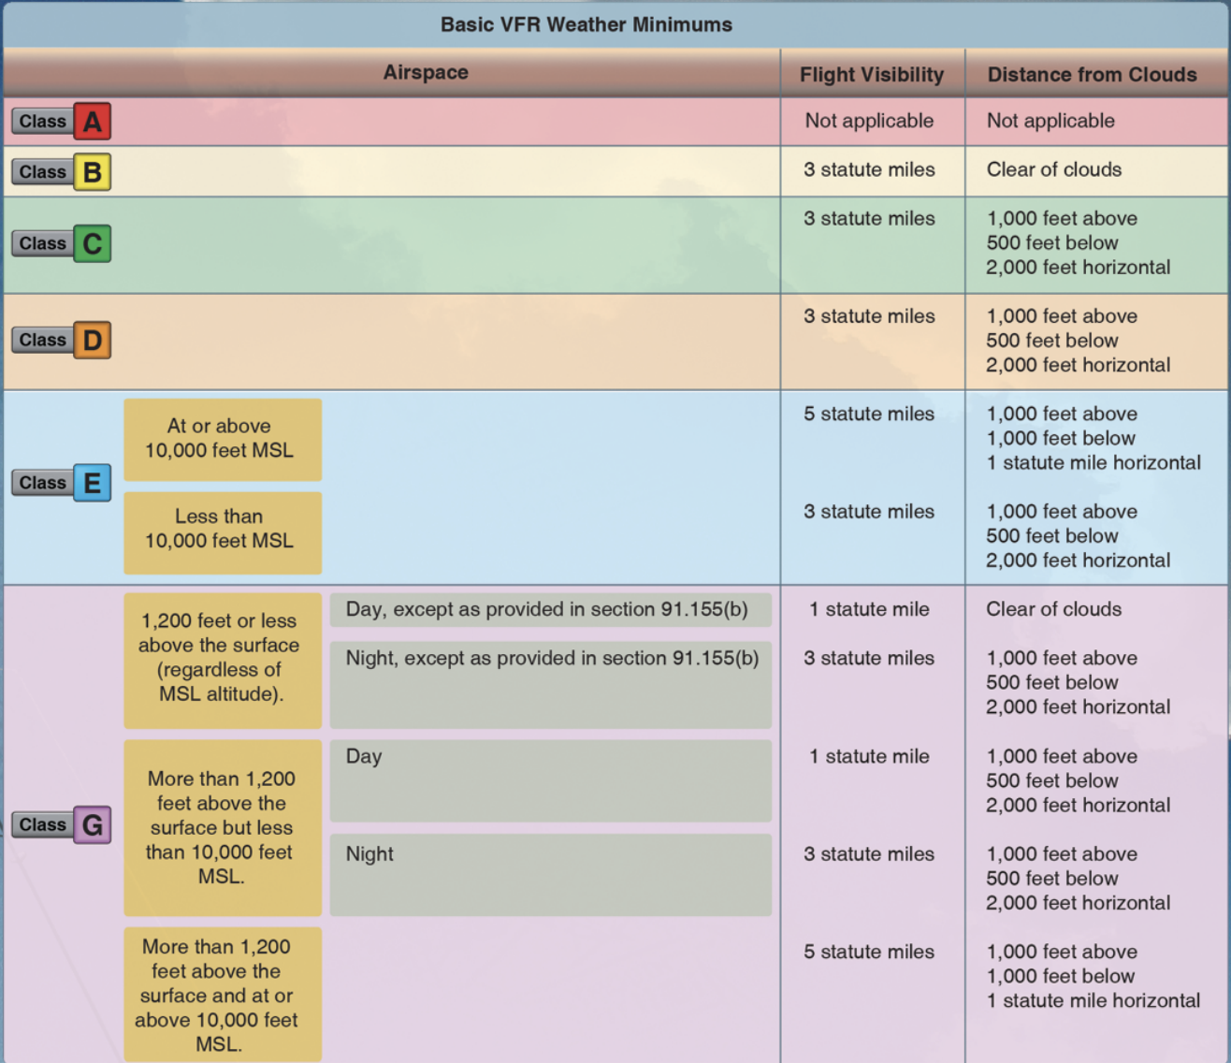

<https://www.experimentalaircraft.info/wx/weather-visibility.php>

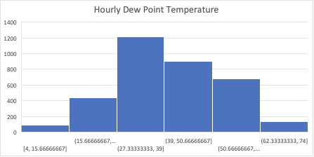

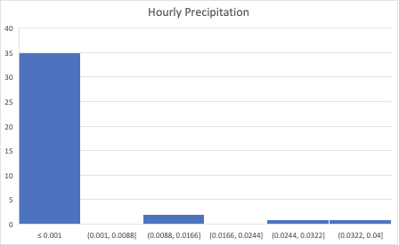

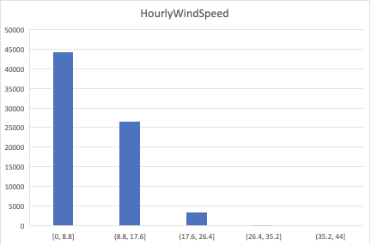

Temperature doesn’t really matter if there is no precipitation (rain becomes snow, ice, etc. vs just rain). A hot or cold day wouldn’t prevent flying.

**My conclusions: We need to look at the flights that were delayed and look at the weather in those conditions. There is no consensus on what exact general of temperature, pressure, humidity, and precipitation would cause a flight to be delayed, only that visibility is affected by all of these factors and the combination of these factors. Once we look at delayed flights, we look at the weather during those times, come up with our number of “bins” and use that as the classification system.**

<https://www.finavia.fi/en/newsroom/2018/four-facts-how-thunder-fog-and-other-weather-conditions-affect-flying>

**THESE ARE NOT MUTUALLY EXCLUSIVE however typically one of them will be the main cause for flight delay**

Icy or snowy: Temperature is below freezing, precipitation is above zero OR humidity is high

Thunderstorm: high pressure, precipitation above zero, temperature above freezing, winds above 50mph

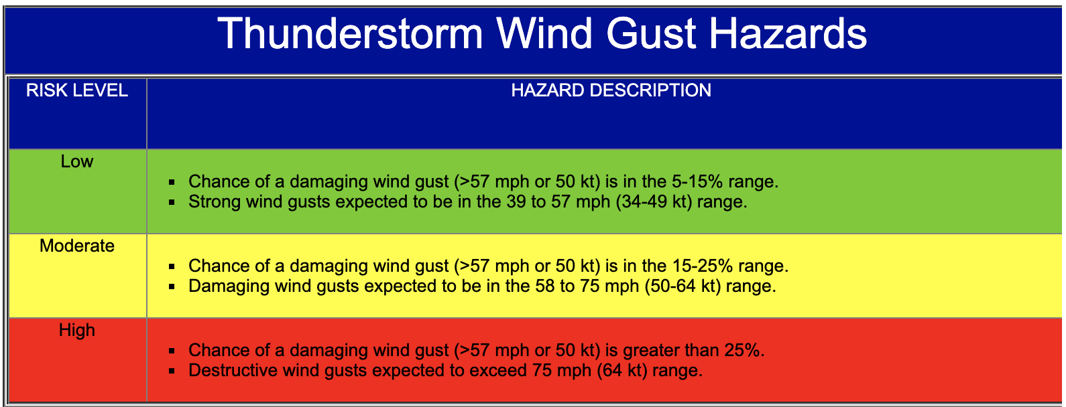

Windy: **gusts**, high windspeed (above 20)

Foggy: high humidity, high dew point, lowered temperature, any precipitation

Suitable for flying: no combination of any of the above risk groups